package ‘zip’ successfully unpacked and MD5 sums checked

package ‘openxlsx’ successfully unpacked and MD5 sums checked

The downloaded binary packages are in

C:\Users\Namita\AppData\Local\Temp\Rtmp8yiH6v\downloaded_packages

library(readxl)

VLBWI <- read_excel("R Datafiles/VLBWI.xlsx")

View(VLBWI)

> dim(VLBWI)

[1] 671 21

race(> dim(VLBWI)

[1] 671 21)

> table(VLBWI$race)

black native american oriental white

369 16 4 257

Gestdata =factor(VLBWI$gest)

summary(Gestdata)

22 23 24 25 25.5 26 26.5 27 27.5 28 28.5 29 29.5 30 31 31.5 32 33

1 11 11 40 1 55 5 66 8 102 4 92 6 83 79 5 55 19

33.5 34 35 36 38 40 NA's

2 14 5 1 1 1 4

bwtdata =factor(VLBWI$bwt)

> summary(bwtdata)

1100 1200 1480 1000 1500 1300 1120 1180 1230 1420 800

21 19 19 17 14 13 12 12 12 12 11

880 920 1250 1360 1400 1450 1140 1240 1280 1320 980

11 11 11 11 11 11 10 10 10 10 9

1290 1340 1350 600 740 760 900 1160 1440 850 940

9 9 9 8 8 8 8 8 8 7 7

990 1060 1310 820 1010 1030 1110 1150 1170 1210 1220

7 7 7 6 6 6 6 6 6 6 6

1330 1370 1390 1460 670 700 780 790 950 970 1070

6 6 6 6 5 5 5 5 5 5 5

1260 1380 1490 500 540 720 805 860 870 910 1020

5 5 5 4 4 4 4 4 4 4 4

1050 1080 1270 610 660 750 770 830 960 1040 1090

4 4 4 3 3 3 3 3 3 3 3

1130 1430 400 550 570 620 630 640 650 652 675

3 3 2 2 2 2 2 2 2 2 2

730 745 765 840 890 905 930 1075 1115 1255 (Other)

2 2 2 2 2 2 2 2 2 2 48

NA's

2

boxplot(VLBWI$gest, ylab="gestational age", main="box plot of gestaional age")

>

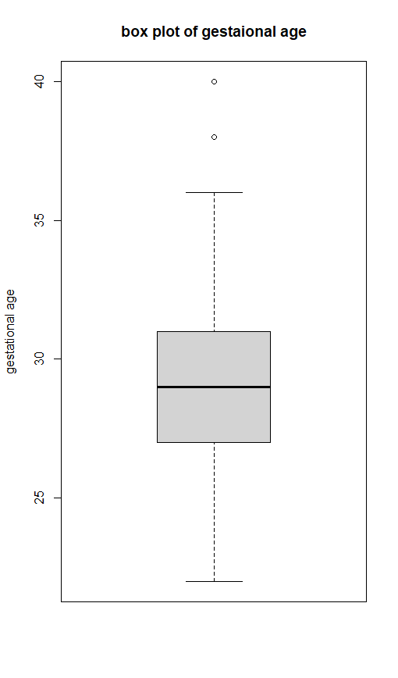

> boxplot(VLBWI$lowph, ylab="lowph", main="box plot of lowph")

hist(VLBWI$gest, ylab="frequency",xlab="gest", main="histogram of gestational age")

lm(formula = lowph ~ gest, data = VLBWI)

Call:

lm(formula = lowph ~ gest, data = VLBWI)

Coefficients:

(Intercept) gest

6.43510 0.02648

Call:

lm(formula = lowph ~ gest, data = VLBWI)

Coefficients:

(Intercept) gest

6.43510 0.02648

> M1<-lm(formula = lowph ~ gest, data = VLBWI)

> SummaryM1

Error: object 'SummaryM1' not found

> summary(M1)

Call:

lm(formula = lowph ~ gest, data = VLBWI)

Residuals:

Min 1Q Median 3Q Max

-0.59350 -0.06660 0.01531 0.09059 0.29593

Coefficients:

Estimate Std. Error t value Pr(>|t|)

(Intercept) 6.435101 0.062129 103.58 <2e-16 ***

gest 0.026477 0.002136 12.39 <2e-16 ***

---

Signif. codes: 0 ‘***’ 0.001 ‘**’ 0.01 ‘*’ 0.05 ‘.’ 0.1 ‘ ’ 1

Residual standard error: 0.1274 on 606 degrees of freedom

(63 observations deleted due to missingness)

Multiple R-squared: 0.2022, Adjusted R-squared: 0.2009

F-statistic: 153.6 on 1 and 606 DF, p-value: < 2.2e-16

---------------------------------------------------------------------------------------------------------------------------------

summary(VLBWI$gest)

Min. 1st Qu. Median Mean 3rd Qu. Max. NA's

22.00 27.00 29.00 28.87 31.00 40.00 4

----------------------------------------------------------------------------------------------------------------------------

plot(VLBWI$lowph, VLBWI$gest, col=c("red", "blue"), xlab="gestational age", ylab="lowph", main="scatter plot lowph and gestational age")S

race_bwtdata=subset(VLBWI, select=c(race, bwt))

> table(race_bwtdata)

bwt

race 400 430 460 480 500 510 540 550 560 565 570 575 580 587 590 600 610 620

black 1 1 1 1 4 0 2 0 0 1 2 1 0 1 0 5 2 2

native american 1 0 0 0 0 0 0 0 0 0 0 0 0 0 0 0 1 0

oriental 0 0 0 0 0 0 0 0 0 0 0 0 0 0 0 0 0 0

white 0 0 0 0 0 1 0 0 0 0 0 0 0 0 0 2 0 0

bwt

race 625 630 640 650 652 660 670 675 680 687 700 710 720 730 740 745 750 760

black 1 1 1 0 2 1 5 1 1 1 3 1 2 2 7 2 1 6

native american 0 0 1 0 0 0 0 0 0 0 0 0 0 0 0 0 0 0

oriental 0 0 0 0 0 0 0 0 0 0 0 0 0 0 0 0 0 0

white 0 0 0 1 0 2 0 1 0 0 1 0 2 0 1 0 1 2

bwt

race 765 770 780 790 800 805 808 810 820 825 830 835 840 850 860 865 870 875

black 2 1 3 1 8 2 0 1 6 1 2 0 1 5 1 1 3 0

native american 0 0 0 0 0 0 0 0 0 0 1 0 0 0 0 0 0 0

oriental 0 0 0 0 0 0 0 0 0 0 0 0 0 0 0 0 0 0

white 0 2 2 4 3 1 1 0 0 0 0 1 1 2 3 0 1 1

bwt

race 880 890 900 905 910 920 925 930 940 950 960 970 975 980 990 1000 1005

black 5 0 4 1 3 5 1 1 5 2 0 2 0 5 5 10 0

native american 0 0 0 0 0 0 0 0 0 2 0 0 0 0 0 0 1

oriental 0 0 0 0 0 0 0 0 0 0 1 0 0 0 0 0 0

white 5 2 4 1 1 6 0 1 2 1 2 3 1 4 2 7 0

bwt

race 1010 1015 1020 1025 1030 1040 1050 1060 1070 1075 1077 1080 1085 1090

black 3 1 3 0 4 1 3 3 3 0 1 2 1 1

native american 1 0 0 0 0 0 0 2 0 0 0 0 0 0

oriental 0 0 0 0 0 0 0 0 0 0 0 0 0 0

white 1 0 1 0 2 1 1 2 2 2 0 2 0 2

bwt

race 1095 1100 1110 1115 1120 1130 1140 1145 1150 1160 1162 1170 1175 1180

black 1 11 5 0 6 2 6 0 3 3 1 4 1 7

native american 0 1 1 0 0 0 0 0 0 0 0 0 0 1

oriental 0 0 0 0 1 0 0 0 0 1 0 0 0 0

white 0 8 0 2 5 1 4 1 3 4 0 2 0 4

bwt

race 1190 1200 1210 1220 1230 1240 1245 1250 1255 1260 1270 1275 1280 1290

black 1 11 1 4 4 5 1 4 2 1 1 0 6 5

native american 0 0 1 1 0 0 0 0 0 0 0 0 0 0

oriental 0 0 0 0 0 0 0 0 0 0 0 0 0 0

white 0 8 4 1 8 5 0 7 0 4 3 2 4 4

bwt

race 1300 1305 1310 1320 1325 1330 1335 1340 1350 1360 1365 1370 1375 1380

black 7 0 2 7 1 4 1 4 6 6 1 4 2 1

native american 0 0 0 0 0 0 0 0 0 0 0 0 0 0

oriental 0 0 0 0 0 0 0 0 0 1 0 0 0 0

white 5 1 5 3 0 2 0 5 3 4 0 2 0 3

bwt

race 1390 1400 1410 1415 1420 1430 1440 1450 1460 1470 1475 1480 1490 1500

black 4 6 2 1 6 3 3 4 4 1 1 8 0 9

native american 0 0 0 0 0 0 0 1 0 0 0 0 0 0

oriental 0 0 0 0 0 0 0 0 0 0 0 0 0 0

white 2 4 0 0 6 0 5 6 1 1 0 11 4 5

bwt

race 1580

black 0

native american 0

oriental 0

white 1

twndata=subset(VLBWI, select=c(twn,race))

> table(twndata)

race

twn black native american oriental white

0 307 15 4 184

1 61 1 0 73

--------------------------------------------------------------------------------------------------------------------------------------

> twn_sex_data=subset(VLBWI, select=c(twn,sex))

> table(twn_sex_data)

sex

twn female male

0 251 263

1 69 66

------------------------------------------------------------------------------------------------------------------------------------

twn_dead_data=subset(VLBWI, select=c(twn,dead))

table(twn_dead_data)

dead

twn 0 1

0 417 99

1 110 25

---------------------------------------------------------------------------------------------------------------------------------

delvery_sex_data=subset(VLBWI, select=c(delivery,sex))

> table(delivery_sex_data)

sex

delivery female male

abdominal 157 155

vaginal 162 173

-------------------------------------------------------------------------------------------------------------------------------

delivery_by_twn=prop.table(table(VLBWI$delivery, VLBWI$twn),2)*100

> barplot(delivery_by_twn)

bwt_sex_data=subset(VLBWI, select=c(bwt,sex))

> table(bwt_sex_data)

sex

bwt female male

400 2 0

430 0 1

460 1 0

480 1 0

500 3 1

510 1 0

540 1 1

550 0 0

560 0 0

565 0 1

570 1 1

575 0 1

580 0 0

587 1 0

590 0 0

600 3 4

610 1 2

620 1 1

625 0 1

630 1 0

640 0 2

650 1 0

652 0 2

660 1 2

670 4 1

675 1 1

680 0 1

687 0 1

700 3 1

710 0 1

720 3 1

730 1 1

740 2 6

745 0 2

750 0 2

760 6 2

765 2 0

770 0 3

780 0 5

790 1 4

800 4 7

805 1 2

808 1 0

810 1 0

820 3 3

825 1 0

830 1 2

835 1 0

840 2 0

850 4 3

860 2 2

865 0 1

870 3 1

875 1 0

880 5 5

890 2 0

900 4 4

905 2 0

910 2 2

920 7 4

925 1 0

930 1 1

940 4 3

950 3 2

960 3 0

970 4 1

975 0 1

980 4 5

990 0 7

1000 8 9

1005 0 1

1010 5 1

1015 0 1

1020 0 4

1025 0 1

1030 4 2

1040 2 0

1050 1 3

1060 3 4

1070 1 4

1075 0 2

1077 0 1

1080 1 3

1085 0 1

1090 2 1

1095 0 1

1100 10 10

1110 2 4

1115 1 1

1120 5 7

1130 2 1

1140 5 5

1145 0 1

1150 4 2

1160 2 6

1162 0 1

1170 4 2

1175 1 0

1180 7 5

1190 1 0

1200 9 10

1210 5 1

1220 1 5

1230 7 5

1240 6 4

1245 0 1

1250 7 4

1255 1 1

1260 1 4

1270 1 3

1275 1 1

1280 6 4

1290 4 5

1300 8 4

1305 1 0

1310 3 4

1320 6 4

1325 0 1

1330 2 4

1335 0 1

1340 5 4

1350 2 7

1360 8 3

1365 1 0

1370 4 2

1375 1 1

1380 5 0

1390 2 3

1400 4 7

1410 1 1

1415 0 1

1420 6 6

1430 3 0

1440 4 4

1450 5 6

1460 3 3

1470 1 1

1475 1 0

1480 8 11

1490 2 2

1500 4 10

1580 1 0